Disaster Relief

Plaster Damage
Historic buildings are particularly vulnerable to vibrations caused by earthquakes. But older buildings also have intrinsic benefits which make them more stable than others. Interior masonry walls, for example, often employ wire lath covered with plaster, which binds materials together for added strength. And while old masonry might crack, it typically will not shift out of plumb enough to collapse.

- Hairline cracks: Almost every plaster wall has a few of these. They can either be canvassed (using fiberglass matting) or filled using a lime (or gypsum) patch. Gypsum is a pre-mixed compound found at the hardware store; a lime patch is one you make yourself combining lime with putty. Although several layers may be required, once the patch is sanded smooth and painted over, both the hairline crack and the repair work disappear.

- Large cracks and small holes typically require the skills of a professional plasterer. Once movement has stabilized, repair work can begin. For cracks, a plasterer chisels the fracture into a V-groove and applies a bonding agent. Thereafter, plaster and lime are gauged, applied, and trowelled smooth. For a hole, the plasterer removes all loose or delaminated material around the hole. Metal lath sections are fastened to the structure and a bonding agent is applied. Larger holes require a base coat mix to accommodate the finish plaster coating, which is polished smooth and flush with the surviving adjacent material.

- Delamination (when plaster separates from its anchors or lath) for small areas requires the same traditional materials used for described finish coats. But reattaching delaminated plaster to lath often requires a system of rekeying using injected acrylic materials. Because acrylic injections must be accomplished from the front of the wall, making the keys difficult to get to, professional plasterers are definitely needed for this work.

- Locating plasterers who are experienced and reputable will be necessary before proceeding with major plaster repair work. References should be investigated. Invite qualified plasterers out to visit the job site to see and define the scope of work. A written proposal and prices from all bidders should then be used for comparison.

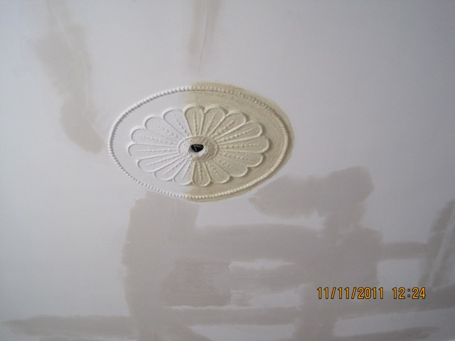
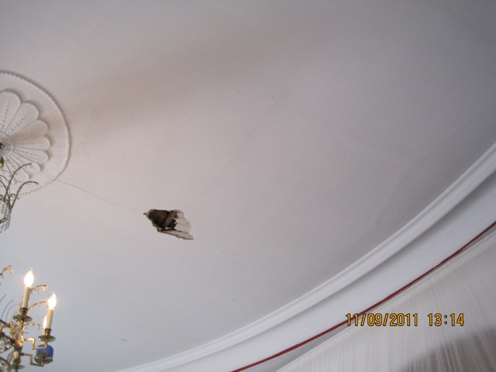

Preservation Brief 21: Repairing Historic Flat Plaster Walls and Ceilings recommends retaining historic plaster if at all possible because much of the building's history is documented in the layers of paint and wallpaper found covering it. When plaster cannot be repaired, it is recommended that the layers of paint and paper be documented in case this information is needed to complete a restoration plan some day. For the full Preservation Brief 21, follow this link: http://www.nps.gov/tps/how-to-preserve/briefs/21-flat-plaster.htm.

Chimney Damage
Following the August 23, 2011, earthquake in central Virginia, chimney damage was among the largest reported problem to DHR from historic property owners. Whether the building was a small cabin, stately dwelling, or campus dormitory, masonry chimneys suffered a wide range of damage. Should the next natural disaster damage wreak havoc on your masonry chimney, keep the following in mind as you plan your repairs:

Safety first. Do not take chances when inspecting damaged portions of a building. Inspect the chimney stack from below or use a window opening if possible. If uneasy with heights, get someone else to do the inspection. Appropriate shoes and a hard hat are recommended. Ladders should rest solidly on the ground and against the wall; do not carry any equipment up the ladder. (No amateur should ever attempt these tasks.)

Chimney Lingo: A chimney has basically three components: a firebox, smoke chamber and flu. The fire box contains the fire. The smoke chamber is the funnel shaped area which is the both chimney foundation and the chamber where smoke begins its ascent through the flue to the atmosphere. It is at this point, (ceiling height) where most structural problems after an earthquake vibration will develop.

About Cracks: The crack width can be used as a guide to the severity of the chimney's problem. Small cracks up to 1/64th of an inch are of no concern structurally. Cracks up to 1/16th of an inch or more should be a concern because water penetration will eventually lead to structural problems. Know that horizontal and vertical cracks of small size are rarely a cause for concern. It's the diagonal crack which indicates when a part of the building has shifted relative to another part.

Repairs: Repairing the masonry damage should be the first consideration. In many cases, cracks need only to be sealed or pointed to prevent the entry of water. While large cracks might require reconstruction of the affected area, dismantling and rebuilding a damaged chimney is typically unnecessary; new construction should only be considered as a last resort. In any case, decisions should only be made after consultation with a historical architect, structural engineer or mason experienced with historic masonry repairs. Generally, an architect or engineer will be most useful at advising you on what to do, while contractors will know most about how to do it. In both cases, try to find someone who has experience with historic buildings instead of new construction.

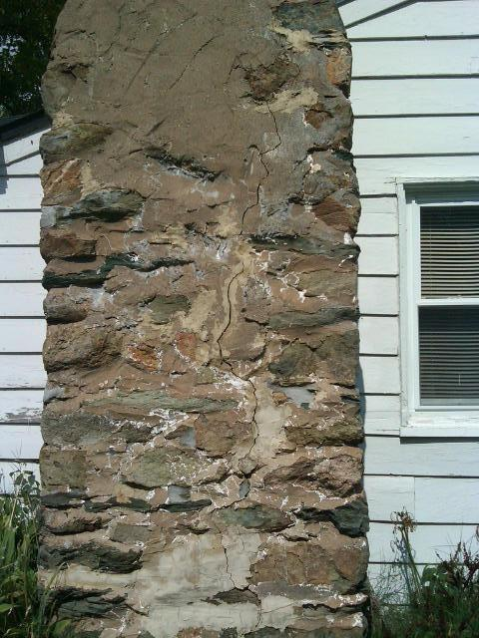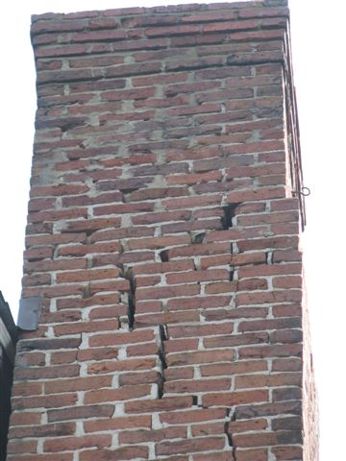

Be prepared: Be informed for consultations with contractors and masons! Check out Preservation Brief 2: Repointing Mortar Joints in Historic Masonry Buildings available at: http://www.nps.gov/tps/how-to-preserve/briefs/2-repoint-mortar-joints.htm.

