Addendum to Highway Marker Memo, March 2023
The Nat Turner Trail, a local marker program sponsored by the County of Southampton, has been added to the agenda for the March 16 meeting of the Board of Historic Resources.
This trail consists of 19 tabletop-style signs (similar to Civil War Trails signs) in the town of Courtland. Fourteen have already been installed, including seven on public property. The Southampton County Historical Society developed the texts.
The Code of Virginia requires that local markers display “prominent notice of the governing body, or its agent, which approved the text of the marker.” These signs do not currently do so. The county plans to procure weather-resistant stickers containing this information. These will then be attached to the signs.
When approving a local marker program, the Board of Historic Resources is charged with reviewing the design (shape, color, dimensions) of the local markers to verify that they are sufficiently different in appearance from the Virginia state highway markers. The board is not responsible for approving the content of the signs.
All signs in the Nat Turner Trail are 36 inches wide and 24 inches tall.

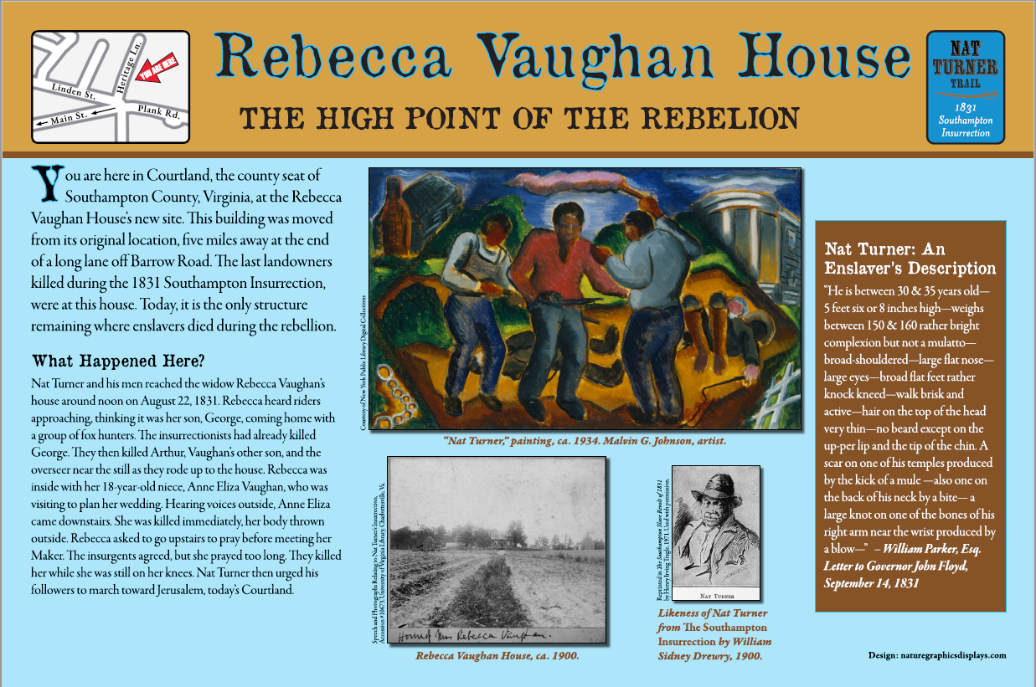

(Additional images below)
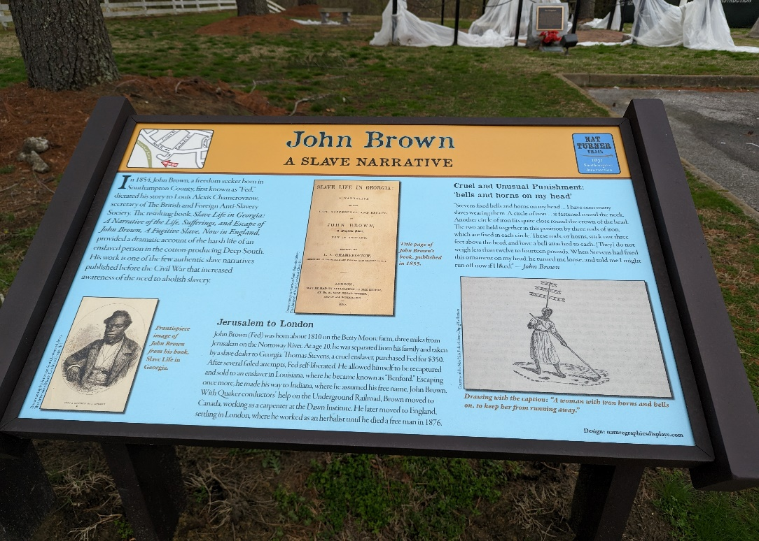

By comparison, Virginia highway markers are 42 inches wide and 50 inches tall, and they stand on a single post.

